Lesson 05

Overview
In this worksheet, we explore specification-driven development by clarifying requirements, tracing an MVC request flow, implementing payment preparation, handling HTTP responses, and testing routes and expected outputs.
Before you answer the questions in this worksheet, you should go through the respective topics in your notes:
Worksheet | Notes
Section A | Specifications Driven Development (SDD)
Section B | Testing
Section C | Submissions

Do seek your lecturer’s advice when in doubt

Section A – Specifications Driven Development (SDD)

Exercise 1
- In C372 project workspace, create a new folder named Week03.
- In the Week03 folder, create a new folder named Lesson05.
- From the Resources folder provided today, copy PetCareAppMVC (This is the same app as what you should have created in week 2).
- Open routes\petRoutes.js, controllers\petController.js and app.js
- Trace the flow of adding a new pet
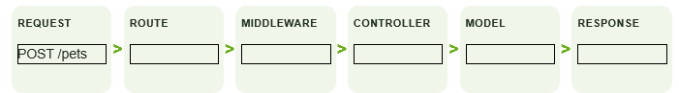
ROUTE: The POST /pets route is used when the user submits the new pet form.
MIDDLEWARE: isLoggedIn checks whether the user is logged in. Multer handles the uploaded pet image.
CONTROLLER: The pet controller receives the form data, processes the uploaded image and handles adding the pet.
MODEL: The model interacts with the MySQL database to save the pet details.
RESPONSE: The user is redirected or shown a response after the pet is successfully added.

Exercise 2
In your teams, discuss:
What does the statement below mean?
"Allow pet owners to prepare payment details for a pet service."
Write at least four clarification questions. Do not code yet.
Include data, success, failure, access and scope questions.
Clarification Questions | Possible response/assumptions
What payment details should the pet owner provide? | Pet service ID, service name and price
What should happened if the payment details are prepared successfully? | The system should display the payment details and a success message.
What should happen if the service ID is invalid? | The system should display an error message and not continue with payment preparation.
Who is allowed to prepare payment details? | Only logged-in pet owners should be allowed to prepare payment details.
Can pet owners change the service price? | No. The price should come from the system and cannot be changed by the user.

Exercise 3
Follow the instructions in your notes. Paste the specifications in prepare-payment.md here
# Feature: Prepare payment details

## 1. User goal

Pet owners want to prepare payment details for a pet service before making payment. This allows them to check the service name and price before proceeding.

## 2. Scope

The feature will:
- Allow logged-in pet owners to prepare payment details.
- Check whether the selected service ID is valid.
- Display the service name and price.
- Show an error message if the service ID is invalid.

The feature will NOT:
- Process actual payments.
- Allow users to change the service price.
- Store payment transactions in the database.

## 3. Request

- HTTP Method: GET
- URL: `/payments/prepare/:serviceId`
- Input: Service ID through the URL parameter.
- Example: `/payments/prepare/1`

## 4. Service catalogue

The system will use a mock service catalogue containing service IDs, service names and prices.

| Service ID | Service Name | Price |
|---|---|---|
| 1 | To be confirmed | To be confirmed |
| 2 | To be confirmed | To be confirmed |
| 3 | To be confirmed | To be confirmed |

## 5. Successful response

- HTTP Status: 200 OK
- Content-Type: application/json
- JSON fields:
- success: Boolean (true)
- serviceId: Number
- serviceName: String
- price: Number

Example response:

{
"success": true,
"serviceId": 1,
"serviceName": "To be confirmed",
"price": 35
}

## 6. Unsuccessful response

If the requested service does not exist, the system will return:

- HTTP Status: 404 Not Found
- Content-Type: application/json
- success: Boolean (false)
- message: String explaining that the service was not found.

Example response:

{
"success": false,
"message": "Service not found"
}

## 7. Acceptance criteria

- AC1: The system allows a logged-in pet owner to prepare payment details.
- AC2: The system checks whether the requested service ID exists.
- AC3: If the service exists, the system returns the correct service ID, service name and price.
- AC4: If the service does not exist, the system returns a 404 error with an error message.
- AC5: The system gets the service price from the service catalogue and does not allow users to change it.

## 8. Open questions

- Should users be required to log in before preparing payment details?
- What are the final service names and prices in the service catalogue?
- Should the response include any additional payment information?
- Should the system support other payment methods in the future?

Exercise 4
Follow the instructions in your notes. Paste the code for the files below:
mockServices.js
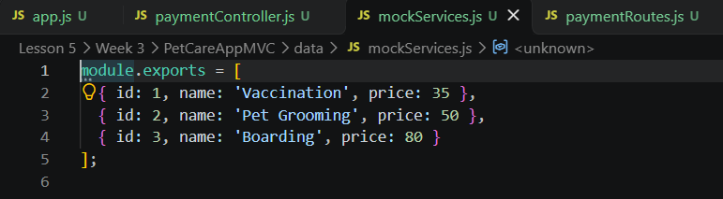

paymentRoutes.js
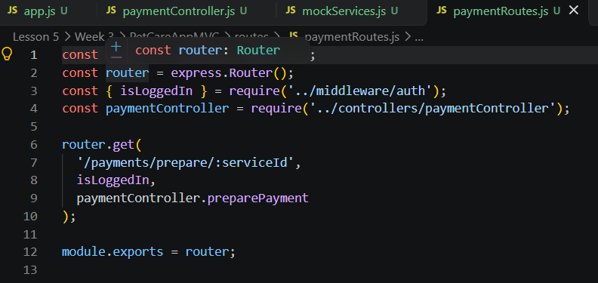

paymentController.js
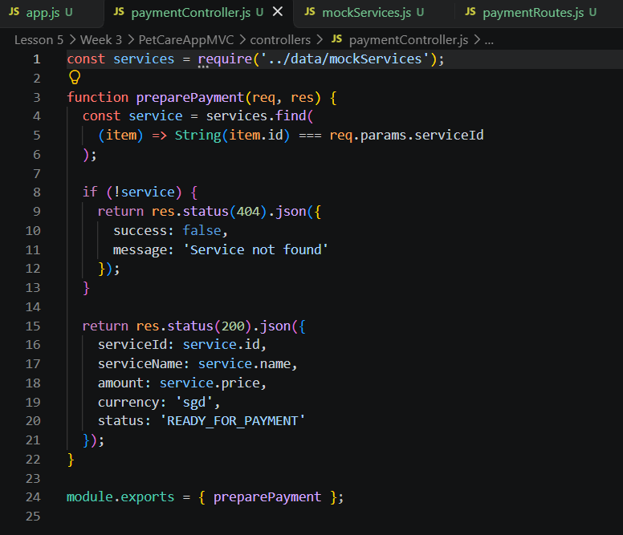

app.js
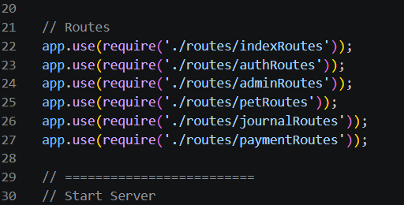

Exercise 5
Fill in the blanks below.

Scenario | Http status codes | Why?
A. Router not registered.  The file exists, but app.js never loads it. | 404 Not Found | The route cannot be found because app.js does not register the router.
B. Route uses :id.  Controller reads serviceId.  :id vs serviceId | 400 Bad Request | The controller does not receive the expected parameter, so it cannot process the request correctly.
C. Price of service is $35, but client sends a modified price  /1?amount=1 | 400 Bad Request | The system should reject the modified price because the actual price must come from the server, not the client.

Section B – Testing

Exercise 6
In this week’s project root, run:
- npm install
- node app.js
Test the following URLs in your browser and record the expected output:
URL | Expected output
http://localhost:3000/payments/prepare/1 | 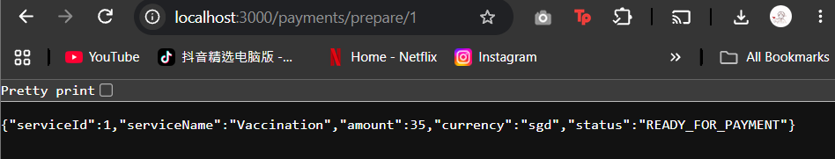
http://localhost:3000/payments/prepare/2 | 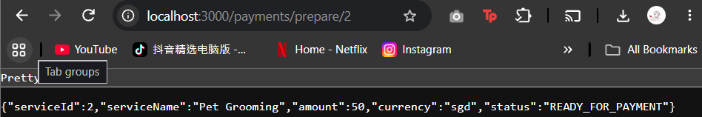
http://localhost:3000/payments/prepare/3 | 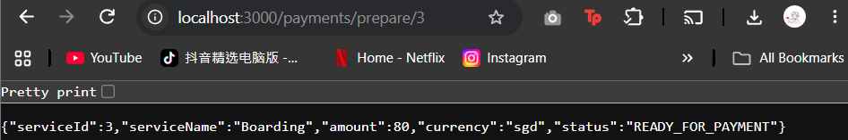
http://localhost:3000/payments/prepare/999 | 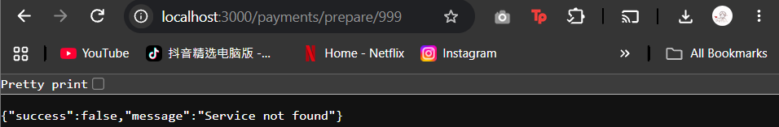

Section C – Submissions
Deliverables for today
- Worksheet (Individual)
- Upload your deliverables to POLITEMALL even if it is incomplete before the next session.
- You can resubmit by 2359 if there are updates.

